1.3 New reservation

Release | 2.4
Logus The Box | Yes, PARTLY

To make a reservation, click the "New reservation" button.

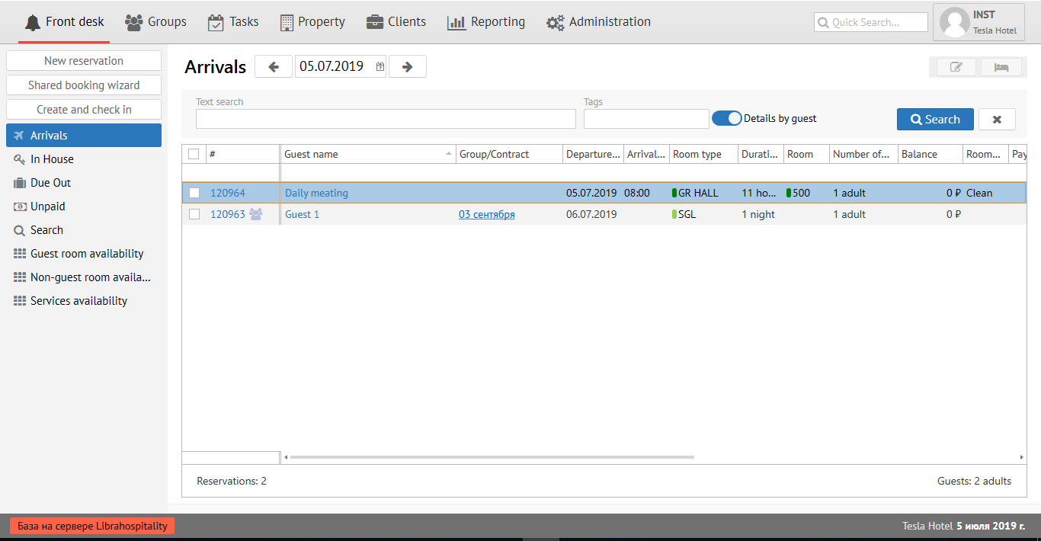

Booking Wizard
Step 1: "Layout and terms"

In the tab "Stay type and terms», it is necessary to fill in the information on the guest:

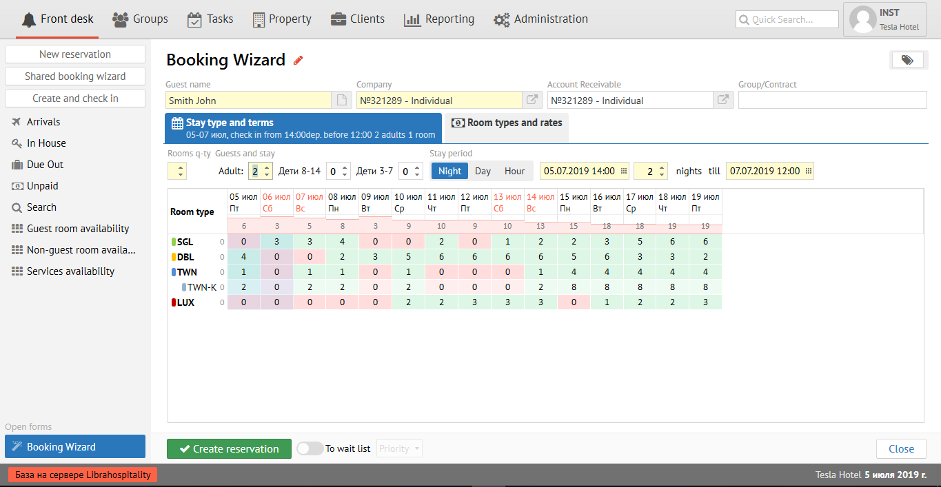

In the field "Guest name", it is necessary to type the name of the guest. If the guest has already lived in your property, a pop-up window will appear in the "Guest name" field with the name and surname of this guest. After clicking on it, all guest information will be automatically filled in to create a reservation.

In the "Company" field, you must select the Client-company from the pop-up menu, whom offered from the list. To do this, you need to start typing the first few letters of the company name and Logus HMS will offer you to choose an existing company from the "Clients" section by itself.

Release | 2.4
Logus The Box | NO

The field "Payer Company" is filled in when the reservation is prepaid by bank transfer. To do this, you need to start typing the first few letters of the company name and Logus HMS will offer you to choose an existing company from the "Clients" section by itself.

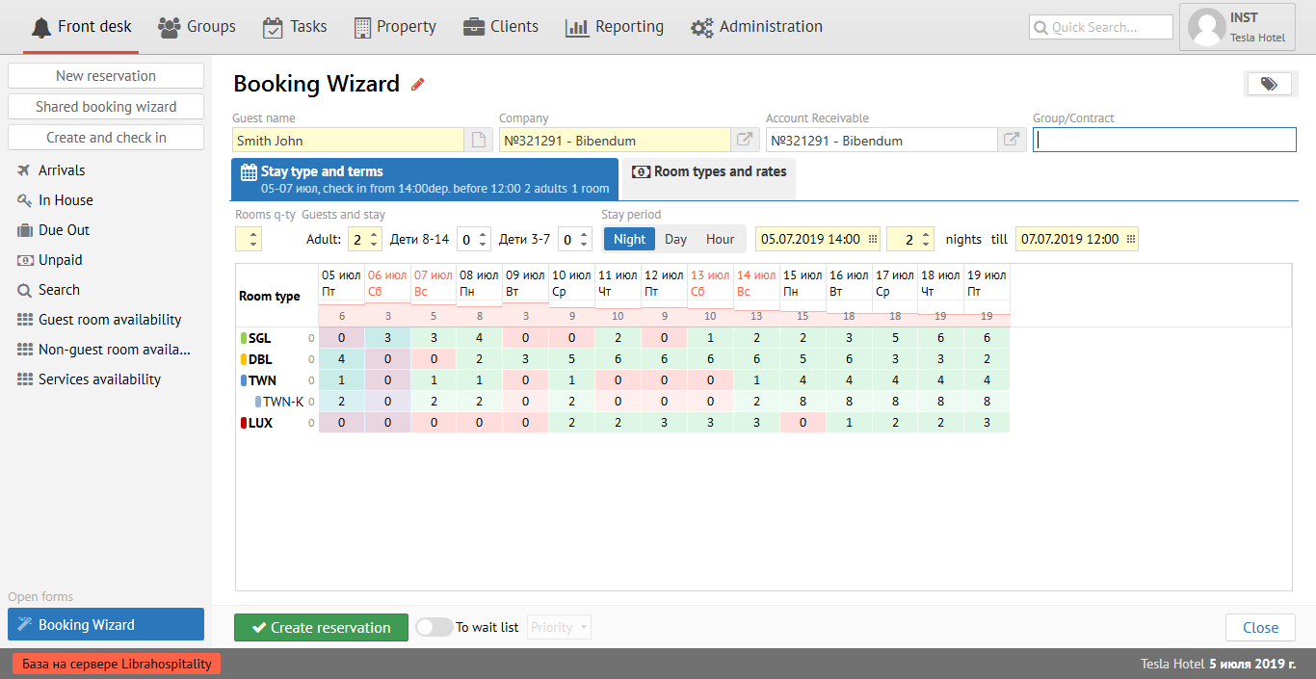

The “Group/Contract” field is filled in if the reservation is made within the existing quota or if you want to add the reservation to an existing group.

Filling out the accommodation scheme in the column "Guests and stay" you must specify the number of adult guests and children. In addition, in the "Stay period" field, you must select the accommodation scheme option (Night/Day/Hour) and enter the reservation dates. For the convenience of entering reservation dates, you can use the calendar.

After entering all the necessary fields in the "Stay type and terms” tab, the Booking Wizard will show you a table of availability for the next period. To select the desired room type and rate, open the next tab, as shown in step 2.

Step 2. "Room Type and Rates"

In the "Room Type and Rates" tab, press left mouse button in the cell at the intersection of the desired room type and the rate.
Note: the system highlights the rate recommended for the selected company.

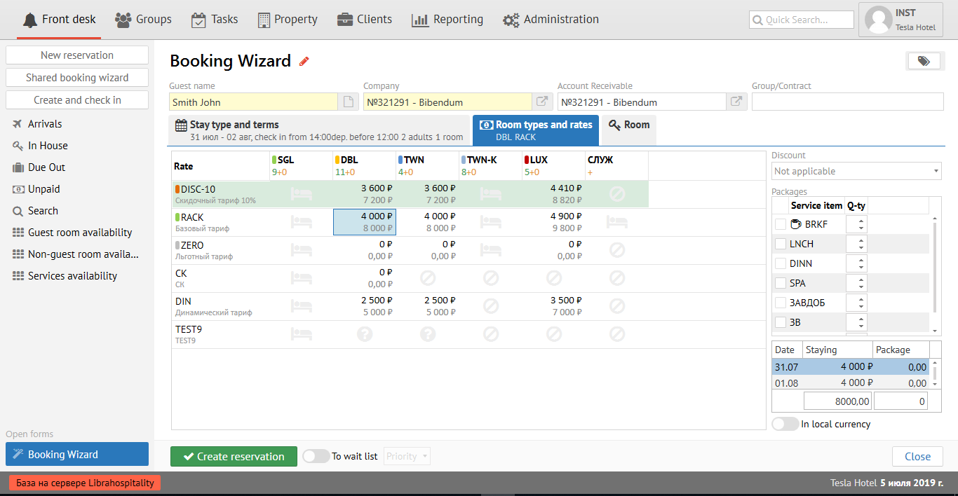

On the right side is the “Discount” field, where you can add a personal discount (5%, 10%, 15%, etc.), and the “Package” field, where you can choose a service (BRKF, LNCH, DINN, SPA, etc.) .d.). Logus will automatically calculate the total cost of the reservation based on changes in the rate.

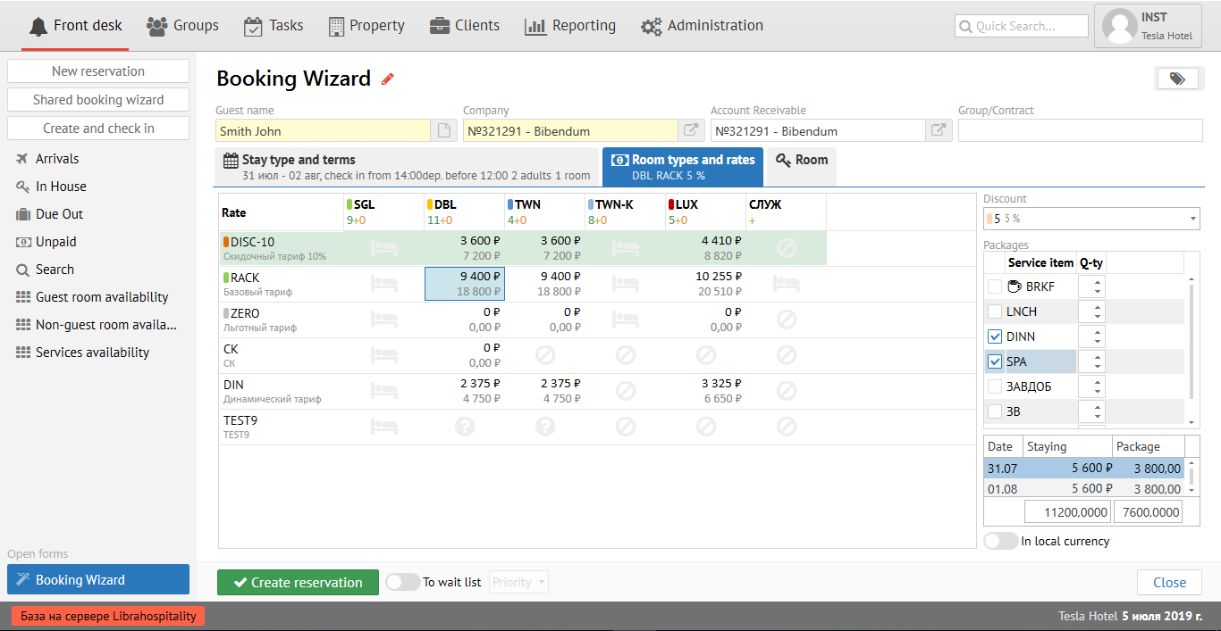

It is also possible to calculate the total cost of the reservation in currency by turning on the "In local currency" button.

Step 3. "Room"

In the "Room" tab, fill in the fields to assign a room to a guest. It’s recommend not to assign a room when booking. Assign it only immediately before checking in a guest!

But if you still decided to assign it in advance, then in the "Location" field from the proposed options, you select the number your guest needs, for example, on the 3rd floor.

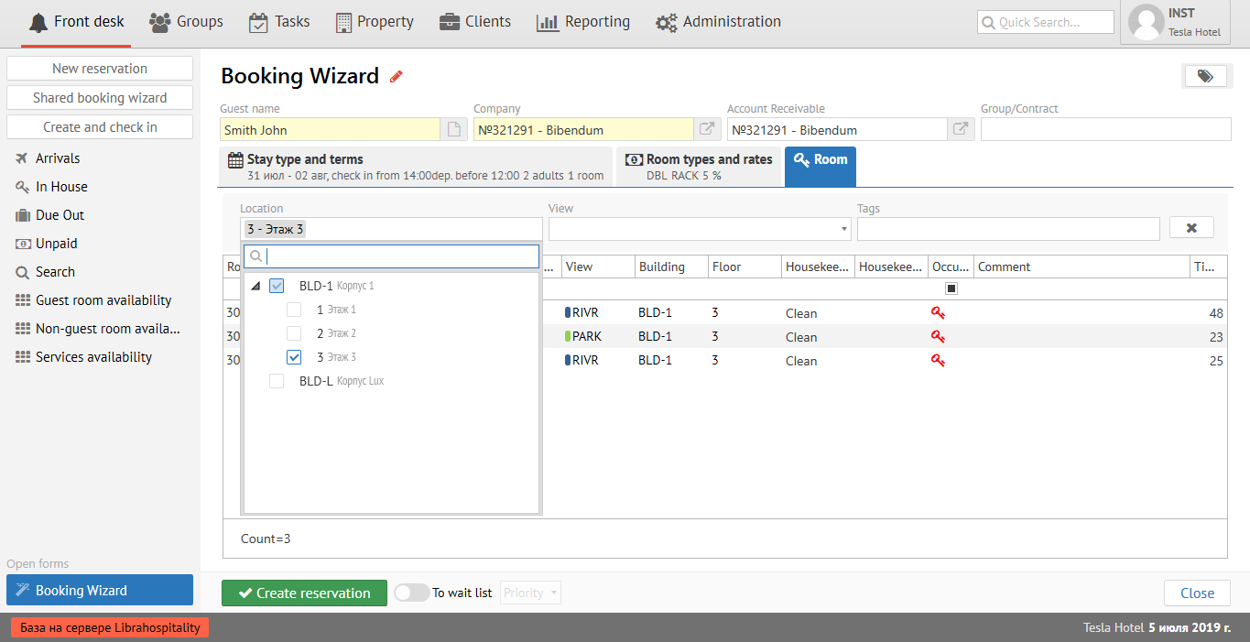

In the "View" field, you need to select the type of your guest’s view from the room’s window, for example, on the river:

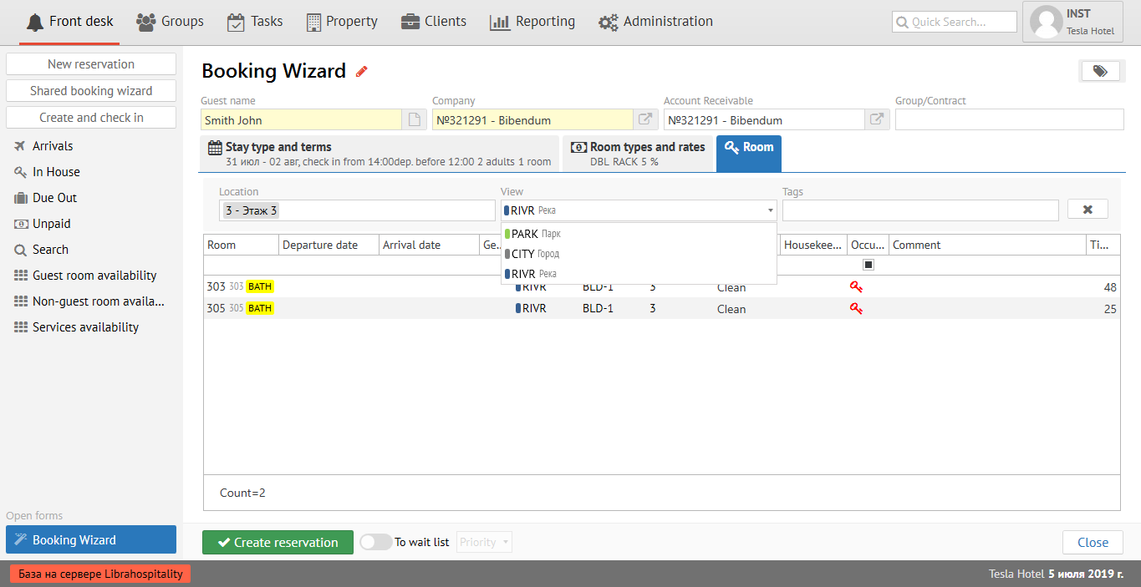

In the "Tags" field, you need to select the room’s tags your guest needs, for example, bathroom.

